Descriptive Analysis of Student Outcomes Across a 15-School District
Dataset: Ninth-grade student dataset for a district with 15 schools (N = 400 students)
Results
- A High Achiever Will Always Be a High Achiever, And Vice Versa
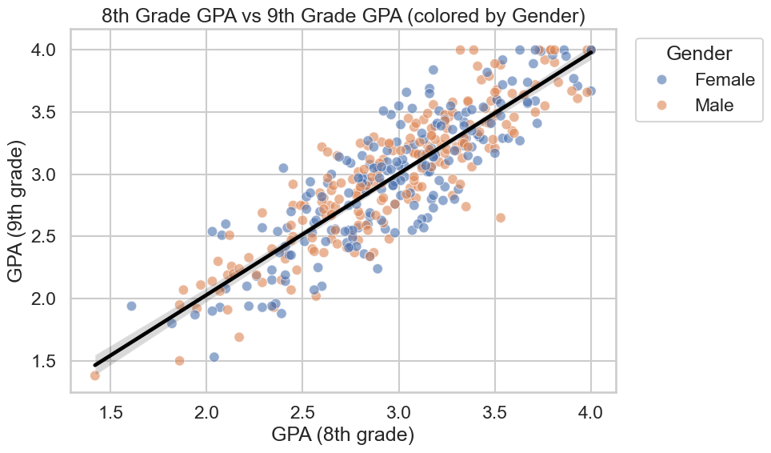
An examination of student GPA from 8th to 9th grade reveals a notable pattern of academic persistence. The scatter plot illustrating 8th-grade GPA versus 9th-grade GPA, segmented by gender, demonstrates a strong positive correlation. This indicates that students who achieve higher GPAs in 8th grade are highly likely to maintain similar academic performance in 9th grade, suggesting a consistent academic trajectory for many students.
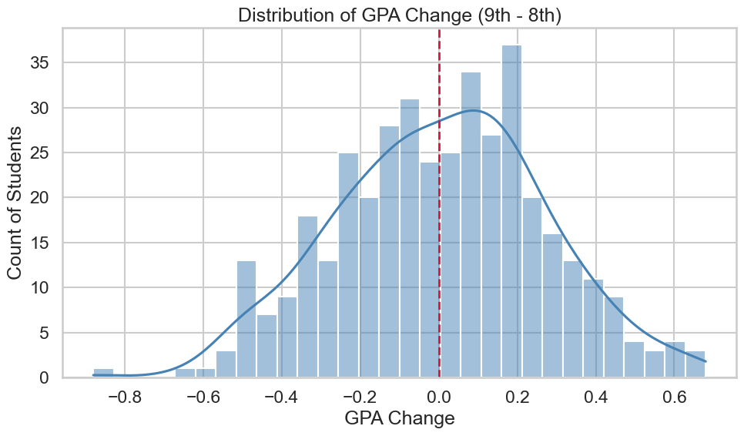
Further analysis of the GPA change (9th grade GPA minus 8th grade GPA) indicates that the distribution is largely centered around zero. As depicted in the histogram in Figure 1, the majority of students experience minimal changes in their GPA between these two critical academic years. While a smaller proportion of students exhibit significant improvements or declines, the overall trend suggests that academic standing established in 8th grade is largely stable as students transition to 9th grade. This finding underscores the importance of early interventions to support students who may be struggling academically even before they enter high school.
- Asians Are the Best in Math Is a Myth
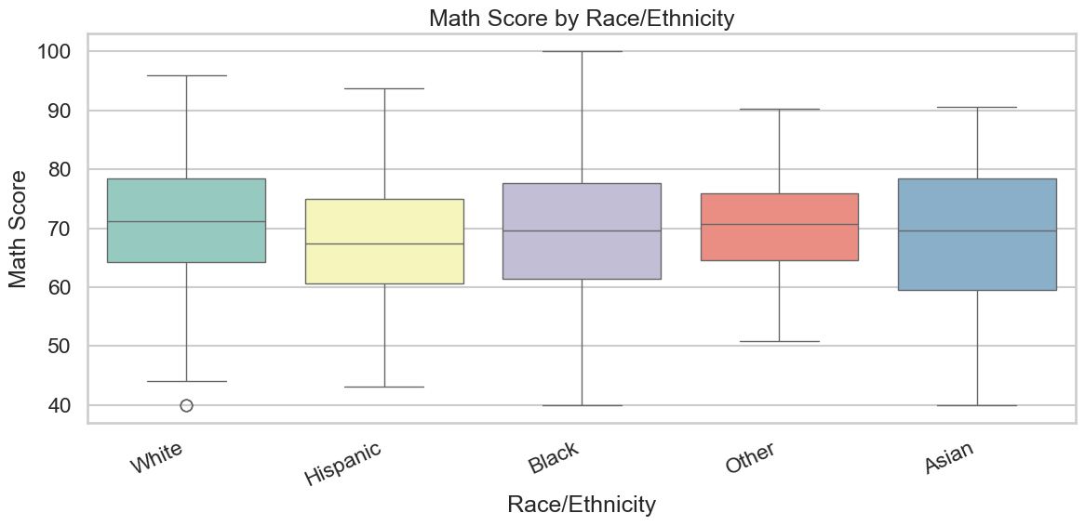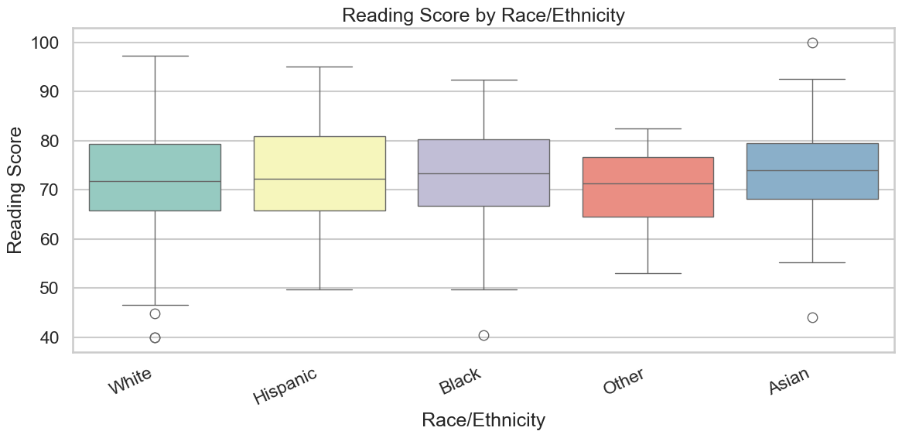

The analysis reveals some observable group-level differences in median scores across various racial and ethnic groups for both math and reading. However, it is crucial to note the substantial within-group variability evident in the box plots. The wide interquartile ranges and presence of outliers within each group indicate that race/ethnicity alone is not a deterministic factor for academic outcomes. Individual student performance varies significantly within each demographic category. This highlights the complexity of academic achievement and suggests that a multifaceted approach, considering various socioeconomic and individual factors, is necessary to address disparities and support all students effectively. Attributing academic success or struggle solely to race/ethnicity is an oversimplification and does not account for the diverse experiences and capabilities within each group.

